Final Web ui to search:
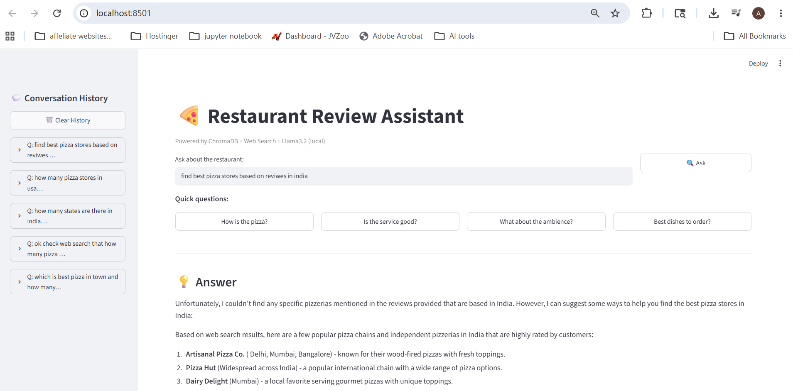

Data in persistent memory can be seen in sqllite. All previous prompts can be read from Sqllite
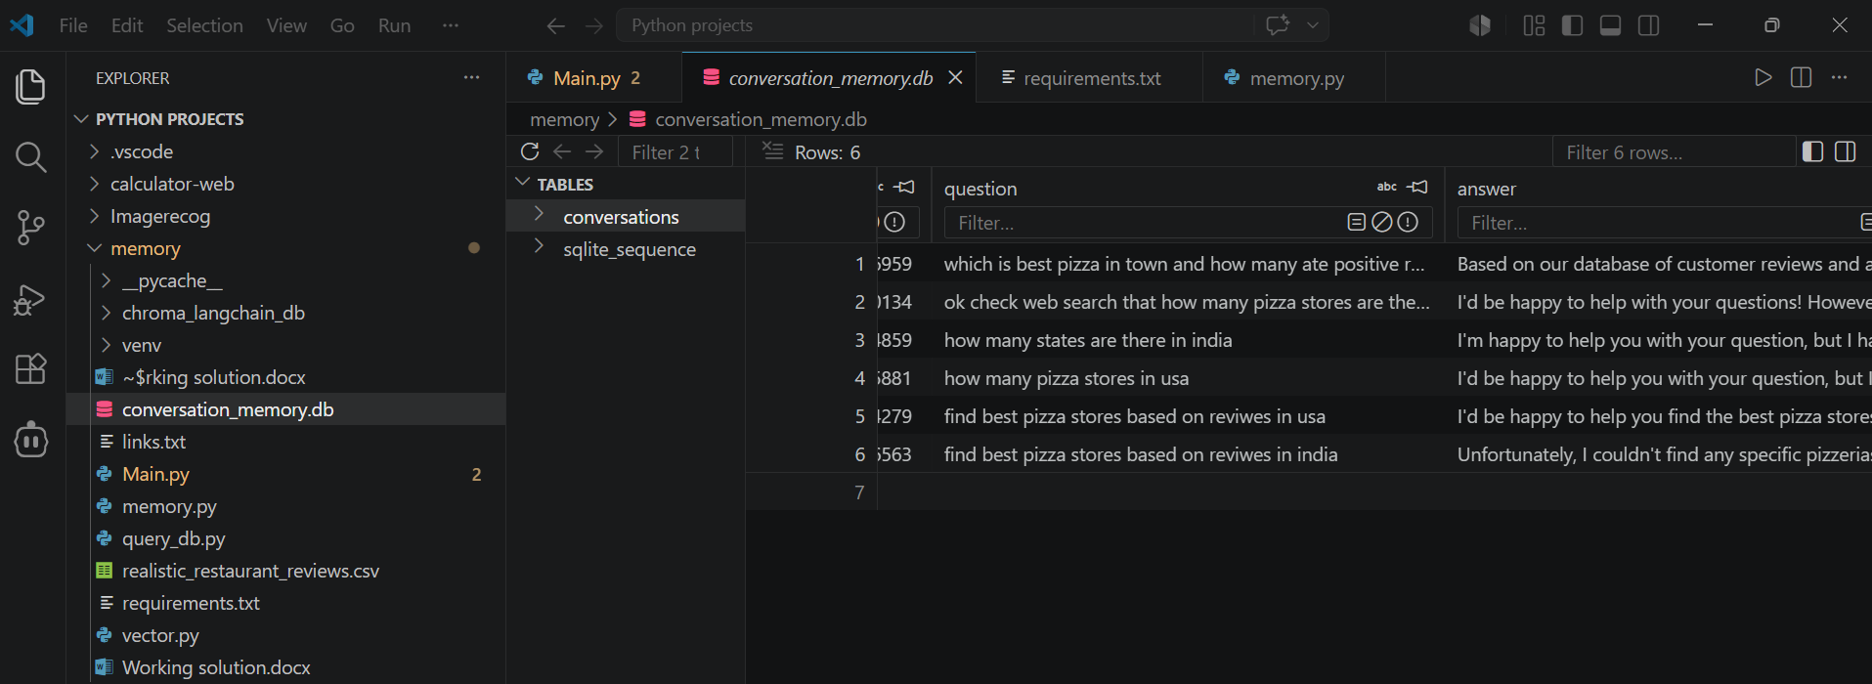

Vector in Chorma DB. Means restaurant review data can be read from Chroma db
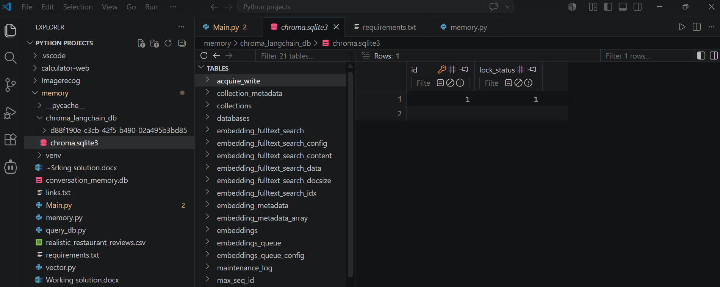

DuckDuckGo and Tavily used for web search
realistic_restaurant_reviews csv file for RAG search

